Mitch Etten-Bohm, President & CEO  Southern Nuclear Operating Company  Components Program Engineer, Pr.  3535 Colonnade Parkway  BIN N-424-EC  Birmingham, AL 35243  Cell: (205) 585-4871  e-mail: mettenbo@southernco.com  Scott Esposito, Vice President  Constellation Energy  Corporate Snubber Engineer  Phone: 888-SNUGINC Ext. 708  e-mail: scott.esposito@constellation.com  Stephanie McCormick, Acting Secretary  Tennessee Valley Authority  Fleet Snubber Engineer  Watts Bar Nuclear Plant  1270 Nuclear Plant Road,  Spring City, TN 37381  Phone: 888-SNUGINC Ext. 710  e-mail: slmccormick@tva.gov  Steve A. Norman, Treasurer & CFO  2168 Harrison Road  Dothan, AL 36303  Phone: 888-SNUGINC Ext. 704  e-mail: sanorman@snuginc.org  Board of Directors  John Catano  Phone: 888-SNUGINC Ext. 701  e-mail: Coachcat78@gmail.com  Scott Fox  Florida Power & Light Company  Phone: 888-SNUGINC Ext. 705  e-mail: scott.fox@fpl.com  Bob Fandetti  e-mail: bob@r-d-racing.com  Timothy D. Canter, PE  Duke Energy  Fleet Engineering Programs - Snubbers  Phone: (704) 382-8876  e-mail: Tim.Canter@duke-energy.com  Mario Mazzuca  PSEG Nuclear LLC  Corporate Program Manager  Mail Code N23  P.O. Box 236  Hancocks Bridge, NJ 08038  Phone: (856) 339-1458  e-mail: Mario.Mazzuca@pseg.com  Nathan Frank  AEP – Cook Nuclear Plant  One Cook Place  Bridgman, MI 49106  Phone: (269) 466-2586  e-mail: NBFRANK@AEP.COM | 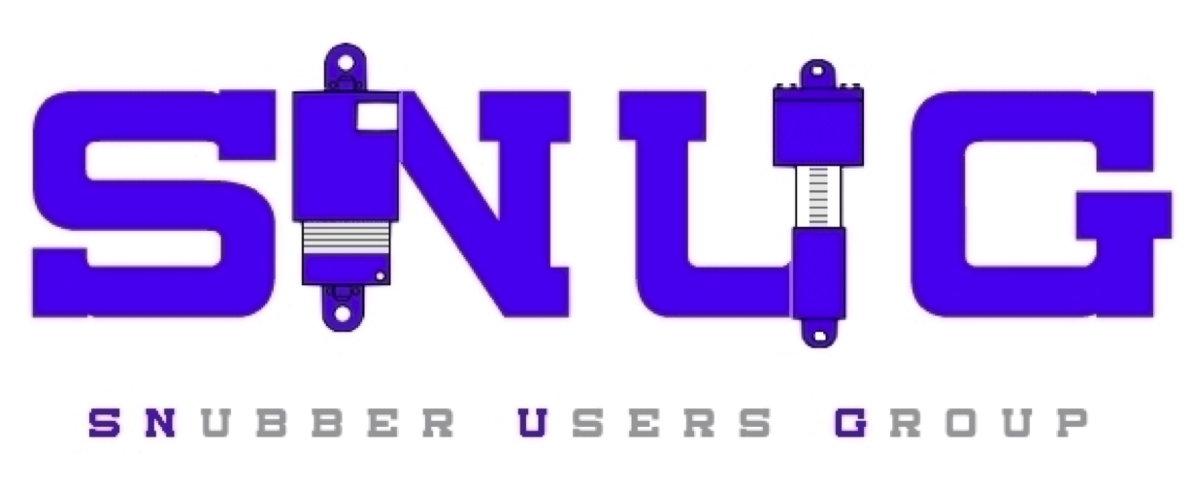  Members, Partners, and Guests  The Summer 2022 SNUG Conference is on! After more than a two-year suspension of face-to-face conferences due to the challenges presented by the COVID-19 virus, we will once again have an opportunity to meet together on Monday, July 18th thru Wednesday July 20th at the Crowne Plaza Downtown University Hotel in Knoxville, Tennessee. We will kick things off with a welcome reception and registration on Sunday evening, July 17th. On behalf of the Officers and Board of Directors, I thank you for supporting this event with your presence and participation. It is my expectation that you will find this conference to be an informative, useful, and enjoyable experience.  For those that may be new to working with or around snubbers, a New Program Owner Training Seminar will be offered first thing Monday morning before the conference officially starts. If you will recall, we originally started our conferences on Monday morning, but in recent years had moved our conferences to start on Tuesday mornings hoping this would make things easier for our outstanding group of support vendors. However, we have found that our original starting day of Monday actually works better because it allows some of our vendors to offer some very beneficial training on the days before and after our conference. We hope you can take advantage of some of their training offerings. Look for emails coming to you directly from vendors in the coming weeks.  This conference provides unique opportunities to interact with all participating vendors during the formal conference sessions and social and meal events. It would be impossible to list all vendor contributions and sacrifices that have been made to make this conference a success. Please join me in thanking all of them for their support while in Knoxville. I would like to thank NTS specifically for sponsoring the conference in Knoxville, which is in close proximity to many nuclear facilities.  We are also excited to incorporate a Maintenance Work Planning and Support session once again into our agenda. Tuesday, July 19th we will have a full day session devoted specifically to personnel who perform Maintenance activities and planning for snubber work. This will run concurrently with an Engineering session to allow more focus on discipline specific presentations and benchmarking. There will also be a session where disassembled snubbers of many types will be on display from participating vendors and utilities to explain how the snubber designs work and answer your questions. Access to vendors will be available to all throughout the conference. Be sure to engage the resources to utilize all the information available.  If you have any questions or comments about the conference, please feel free to contact myself or any of the Board members. The agenda is still in progress, but the draft and the hotel registration information are on the new SNUG website here, SNubber User Group (snuginc.org). Registration instructions are included below as well.  In addition, we are calling for nominations for anyone interested in serving on the SNUG Board of Directors. Elections for new Directors will be held at the conference, during the Business Meeting session. Please contact me by email at mettenbo@southernco.com if you are interested or wish to find out more about the responsibilities for SNUG Directors. For new officers, it is typically some conference preparation duties and participation on a 1-hour/month Board of Directors call.  Register for the 2022 SNUG Conference, Crowne Plaza in Knoxville, TN, July 18– 20  - To register with SNUG for the conference, click here: Register for SNUG. If you have not already gained access to the webpage, follow the instruction and access will be granted.  - To reserve your guest room at the Crowne Plaza, click here: Reserve your guest room at the Crowne Plaza  - Make sure that the dates shown are the dates you will be arriving and departing. Change them if necessary (it typically defaults to the current date).  - When the dates are correct, click the “SEARCH” button.  - The code SNU should show up in the Group Code box (if the code doesn’t appear in the box, type it in).  - Make your room selection  - If you click “Select Room”, it will take you where you can pay for your room.  See you in July!  Sincerely,  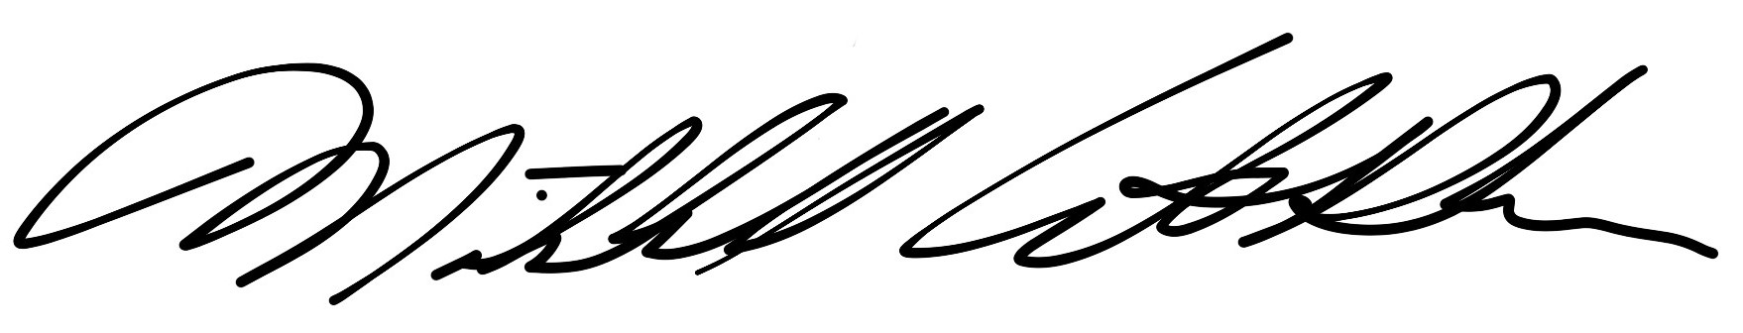  Mitch Etten-Bohm  President and CEO  SNubber Users Group

